Frequently Asked Questions (FAQ) for "Genetic associations with educational fields"

By Rosa Cheesman. rosacg@uio.no

Box: Key terms
- Educational fields are domains of knowledge, skills, and competencies that are the subject matter of an education program, qualification, or degree. We study 10 broad fields of education defined by ISCED (International Standard Classification of Education). ISCED fields are standardized categories for classifying educational content at an international level, designed primarily for statistical reporting and comparison across different countries' education systems. We study educational field qualifications at all levels, not just school subjects or college majors. The focus is on educational qualifications not occupations or labour market sectors, which may align but are not identical to educational fields.
- A genetic association refers to a statistical relationship between a specific genetic variant (or multiple variants) and a particular trait or condition. When a genetic variant occurs more frequently in people with a certain characteristic than would be expected by chance, we say there is an association between that variant and the trait.
- The GWAS (Genome-Wide Association Study) is a research approach that examines millions of genetic variants across the human genome to identify which variants are statistically associated with a particular trait, disease, or condition. GWAS compares the genetic profiles of many individuals (in this study, 460,000) to detect variants that appear more frequently in people with the trait of interest compared to those without it.
- Genetic variants are differences in DNA sequences that occur among individuals. These are the natural variations in our genetic code that make each person genetically unique. We study the most common type of genetic variants known as Single Nucleotide Polymorphism (SNPs). Here, a single base pair (A, T, G, or C) in the DNA sequence differs from the usual base at that position. For example, a DNA sequence might read AAGGCT in most people, but AAGGTT in some individuals.
- A polygenic index (also called polygenic score or polygenic risk score) is a numerical value that summarizes the estimated effect of many genetic variants on an individual's phenotype (observable trait). It's calculated by summing the effects of multiple genetic variants, each weighted by the strength of its association with the trait. Polygenic indices are used to predict genetic predisposition to complex traits that are influenced by many genes, such as educational attainment, height, or disease risk.

What was the motivation for the study?
The choice of a field of study is one of the most profound decisions we can make. Field of education can significantly influence important outcomes like our income, and fertility, even when educational level is held constant. On a societal level, the systematic sorting of individuals into different fields shapes who acquires the skills specific employers want and thereby determines the distribution of rewards. Field-related social inequalities have been intensifying: as access to higher education expands, the specific area of study can increasingly influence life outcomes.

We know that social forces are important for field of study, and we also know that there is a genetic component to our behaviours and our educational trajectories. But what we don’t know is how genetic and social forces combine to influence who is getting what qualifications. The aim of this project was to fill this gap. We realised that massive scale genetic data could be used to reveal novel and replicable information about the interests that drive us and the social inequalities that structure our lives.

Our goals were to:
- Explore whether genetic variants are associated with different kinds of qualifications, not just levels of qualifications.
- Identify clusters of fields that share a genetic basis. Individuals tend to only specialize in one field, making it difficult to understand similarities across fields. For example, we don’t know whether there are any overlapping influences on choosing STEM versus Arts subjects. We use a new genetic method that can measure the similarity of two traits even if they are measured in two different groups.
- Describe the complexity of educational fields in terms of how they relate to myriad human traits, behaviours, diseases and positions in society. There has been some research on factors linked to educational fields (e.g., income, fertility), but we wanted to use genetic methods to expand the scope of the evidence and look at personality, mental and physical health, life satisfaction and more.

Who conducted this study?
The authors of the article are an interdisciplinary team of statistical geneticists, personality psychologists, economists and sociologists based in Norway, Finland and the Netherlands. Large scale collaboration is necessary for genome-wide association studies, which require large sample sizes to successfully identify genetic associations. The article bridges previously disconnected domains: the genetics of complex traits, on human interests and personality, and on educational sorting and inequality in society. This integration demanded diverse expertise from all coauthors, whose complementary specializations enabled us to develop more comprehensive theoretical frameworks and methodological approaches than would have been possible within a single discipline.

What did we do?
We investigated whether and how genetic factors are associated with what field people study, from fine art to finance.

We brought together a huge dataset of 460,000 genotyped people from across Finland and Norway and looked at the full range of qualifications they were recorded to have studied in the national educational registers. We followed international convention from the European Commission and looked at 10 broad field categories: Education; Arts and humanities; Social sciences, journalism and information; Business, administration and law; Natural sciences, mathematics and statistics; Information and Communication Technologies; Engineering, manufacturing and construction; Agriculture, forestry, fisheries and veterinary; Health and welfare; Services. The most common field codes were Engineering, manufacturing and construction and Health and welfare, whilst the least common were Agriculture and Natural sciences, mathematics and statistics.
The four main aspects of the study were:
- To identify any links between genetic variants and educational fields, we used a well-established approach called a genome-wide association study (GWAS). GWAS allows us to scan across millions of genetic variants in the human genome to see if some occur statistically more often in people studying specific fields e.g., Social sciences than in people who did not specialise in that field. We did 10 genetic association studies (one for each field of education).
- We then explored overlap in the genetic variants associated with different fields, e.g., to what extent do similar genetic variants play a role in specialising in Natural sciences and Social sciences?
- To make the complex interrelationships between all the fields more interpretable, we applied another well-established method called principal component analysis to simplify our genetic results. We identified a smaller number of key components to describe the main ways that people are sorted into groups of fields.
- We explored in depth what the components of field qualifications mean by looking into how they correlate with ~100 other traits, behaviours, diseases and inequality indices analysed in external genetic studies.

We did lots of other analyses to validate and probe our findings, as detailed in the paper.

Who did we study and why does that matter?
Our study was based on cohorts from Finland and Norway. These countries have high-quality administrative records of their whole populations’ educational pathways, enabling us to assemble a huge amount of data and harmonise it so that participants’ age ranges and field categories match.

The Nordic context of our study is characterised by free education, universal stipends, and student loans with low interest rates to cover living expenses. This is an advantage when it comes to identifying genetic associations, because it increases the chances that we pick up on mechanisms involving genetically influenced interests and skills, rather than only non-genetic factors like tuition fees and family resources (although this signal is interesting too). Nonetheless, social inequalities still exist. Wage gaps between fields, and strong normative cultural beliefs about gender in Nordic countries also mean that our study does not purely capture individual interests.

The Nordic context does not necessarily generalise well. In countries with higher social inequality than in Finland and Norway (i.e., most countries!), where the socioeconomic consequences of some field choices are riskier, the heritability of field choices might be lower, and links with individual interests and preferences might be less prominent. Our results pertain to a specific cohort and socio-political context and would likely change along with changes to how people sort into fields. For example, the results might differ if people were encouraged to explore a wider range of subjects, if the skills involved in certain fields were different, or if the gender norms or economic returns to fields changed.

We also note the major limitation that only Norwegian and Finnish individuals with European-associated ancestries were included in the study. It remains unclear how much the results generalise to people of diverse ancestral backgrounds. Future work should include underrepresented groups and countries to increase generalisability and avoid reinforcing socioeconomic and health disparities.

With these caveats in mind, our study is a great starting point for understanding the role of genetics in educational field choices.

What did we find?

- Genetic differences between people are associated with differences in what field they study.

Commonly occurring genetic variation in the population was found to be significantly associated for all the 10 fields. This is the first time genetic associations with fields have been shown. As with all complex human outcomes, each genetic variant has a miniscule effect on its own. To the extent that a given genetic variant influences educational field qualifications, it does so in combination with other variants and with environmental experiences. When we analyse all common genetic variants together, they capture between 3% (for Health and welfare) and 14% (for Natural sciences, mathematics and statistics) of the individual differences in educational field specialisations.

- There are underlying interrelationships between field specialisations.

Even though each participant could only be observed in one category, we were able to demonstrate patterns of clustering between diverse educational fields using genetic data. For example, genetic differences linked to pursuing Social sciences, journalism and information are also strongly associated with studying Arts and humanities but not at all with studying Natural sciences, mathematics and statistics.

- Two key distinctions are important in how people sort into educational fields: Technical versus Social, and Practical versus Abstract.

We extracted key components explaining the genetic clustering across fields. We label the first component ‘Technical versus Social’ because it indicates how much each field involves things (like bridges and numbers) versus people. Engineering is strongly Technical, whereas Education is on the Social end of the spectrum. We label the second component ‘Practical versus Abstract’ as it seems to reflect hands-on, pragmatic as opposed to theoretical and creative activities. More Practical fields include Services and Health and welfare, whereas more Abstract fields include Social sciences, journalism and information, Natural sciences, mathematics and statistics, and Arts, humanities and languages.

Interestingly, the structure behind different educational pathways that we elucidated chimes with social science theories. This includes not only the well-known RIASEC vocational interests model used by careers advisers to help people choose their life path, but also sociological theory on the key resources that specialised educational programmes provide. This striking alignment between social science theory and number crunching of massive genetic data shows how genetic differences reflect the social structure, and how genetic research complements social science enquiry.
- Genes linked to Technical-Social and Practical-Abstract field components are also associated with many sorts of domains including personality, mental health, substance use, health, fertility, and socioeconomic status.

Genes don’t operate in a vacuum but are expressed via interplay with our environments throughout our lives. As a result, genetic associations are a microcosm of all the psychological, social, geographical and cultural factors linked to field specialisations. To bring out these patterns, we examined how Technical-Social and Practical-Abstract qualifications link to ~100 traits.

Some of the results reflect plausible psychological mechanisms. The Technical-Social component is genetically correlated with traits that arise early in life and relate to being interested in people, such as extraversion, agreeableness (higher on the Social end). Similarly, this component overlaps genetically with non-cognitive skills (also known as ‘socioemotional’ skills), frequency of family/friend visits, and number of sexual partners. The Abstract-Practical component also relates to individual tendencies towards open personality and creativity. The tendency to study Abstract rather than Practical educational fields is genetically correlated with higher predisposition to schizophrenia and bipolar disorder, consistent with studies showing that relatives of people with these mental health conditions are more likely to have creative professions.

Our results also appear to capture wider patterns of social stratification. The Abstract-Practical component is clearly related to traditional socioeconomic indicators such as occupational status. Unlike Practical fields like education and healthcare, which are oriented towards welfare state jobs, Abstract qualifications often lead to elite professions in media, politics, research, law, and the arts, which are typically more accessible to individuals from advantaged families. Therefore, our genetic findings might be capturing social and economic resources.

Interestingly, our genetic results paint a more nuanced picture of social and economic variation in the population than is possible when only looking at conventional status markers. It appears we may also be identifying some disadvantages of elite educational paths. For example, the propensity to study Abstract rather than Practical educational fields is related to socioeconomic instability such as more loneliness and divorce, lower relationship satisfaction, lower vitamin D levels, and higher risks of psychiatric disorders.

Overall, our genetic associations likely pick up on a mixture of causes, consequences, and correlated contexts of educational specialisations, which can be further clarified in future research. We have massively expanded the scope of research on the role of educational fields within the social and life sciences, and generated lots of interesting data and tools for downstream investigation across disciplines.

Did you find the gene or genes for any kind of field specialisation?
No, we did not identify specific genes that directly determine field choices. Our research demonstrates that field specializations, like most complex human behaviours, are influenced by many genetic variants across the genome, each with a very small effect. Rather than finding a few "genes for" field specialization, we discovered polygenic signal—patterns of many genetic variants that collectively show small but measurable associations with different field preferences.

Why are genetic variants associated with fields of education?
The sections above highlighted that genetic influences are always mediated through the environment, and that the Nordic context of the study must be kept in mind when thinking about possible explanatory mechanisms. The figure below brings together the various contexts that individuals are situated in and move through that affect their field of study outcome, all of which end up being captured in genetic studies.
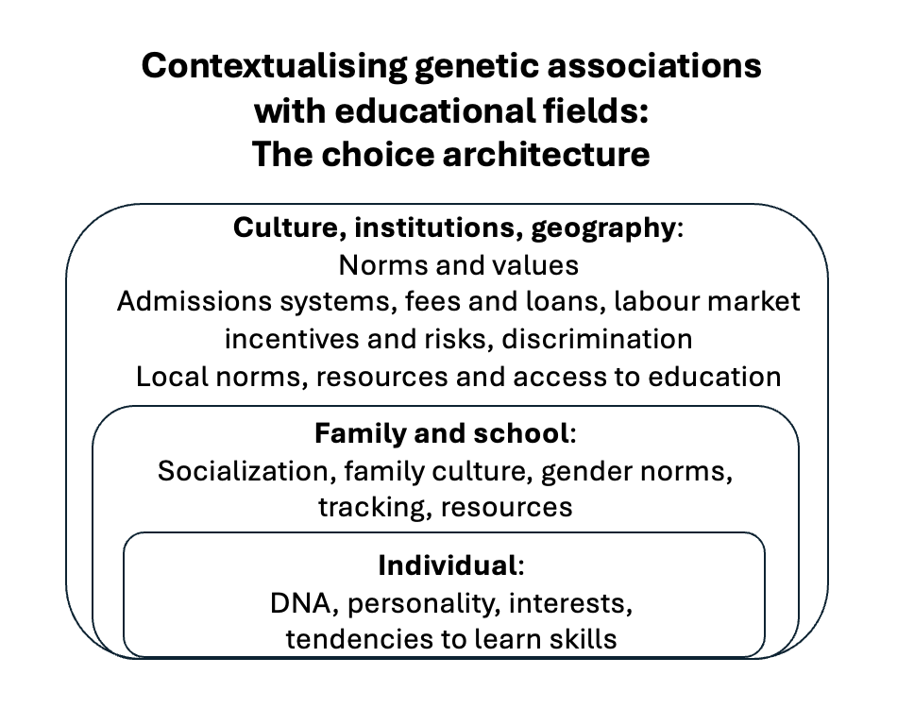
Even in Finland and Norway, educational field choices are constrained and amplified by a multitude of proximal and distal social factors. An individual would not study fine art if they had never heard of fine art or been exposed to encouragement suggesting that it is a suitable choice for them. To the extent that genetic variants contribute to field qualifications, they do so via gene-environment interplay mechanisms, whereby field-related interests and skills are selected and elicited by individuals based on their heritable traits. Such mechanisms are likely to begin early in life, involving parents, teachers, and other role models. Gender norms are a key social mediator, with stereotypes that influence choice of field of study beginning early. For instance, both girls and boys tend to be steered away from female dominated educational tracks, and the gender gap in STEM degrees is partly because boys benefit from teacher biases. Results could also capture downstream effects of education program prerequisites (e.g., if technical skills are necessary to gain entry to engineering training, then engineers will on average have higher genetic values for technical skills) and pick up dropout due to poor person-environment fit or discrimination. In conclusion, our results reflect the interplay between individual tendencies, social norms and barriers affecting educational qualifications.

Are there any practical uses of genetic results for individuals and policymakers?
An exciting advance in recent years has been the development of individual-level measures of genetic predisposition to traits and diseases – polygenic indices (PGIs). In our study, we show that the genetic association results can be used to create PGIs for specific fields of study in a completely independent Dutch cohort. We saw that participants’ PGIs for fields were significantly associated with their actual field of study.

Could PGIs be used to help us make educational decisions? It has been argued that PGIs could provide early warnings for dyslexia ((Plomin 2018, Plomin & von Stumm 2018)). Many of us would be keen to know any information that helps match us with an educational programme.

However, there are technical issues to consider. First, PGI prediction accuracy is extremely weak. Even the strongest PGI predictor, the Arts and humanities PGI, was associated with a miniscule change in log odds for studying Arts and humanities (0.22). Second, we have not even begun to develop PGIs for educational fields in non-European people. Since polygenic Indices (PGIs) derived from one ancestry group cannot be reliably applied to another group, we risk exacerbating existing socioeconomic and health inequalities if these European-derived results are implemented in practice. Our findings show diminished accuracy for individuals with lower genetic similarity to commonly used genomic training sets. These training sets predominantly comprise samples from individuals with recent European ancestry, reflecting a persistent limitation in genomic research. Third, as we have described in the sections above, our genetic association results do not only capture individual interests and skills but a host of other contextual factors like family resources and gender norms. If PGIs are not just personal but circumstantial, this is another way in which using them in practice could exacerbate socioeconomic disparities. To try to establish causality, we conducted analyses controlling for birthplace and parents’ education, and we also tested the accuracy of our PGIs within sibling pairs. Although we did not see any strong evidence that PGIs were capturing family environmental and geographical processes, we did not have the statistical power to rule this out completely.

Even if the technical issues were solved and we had PGIs that offered unbiased prediction of our fields of study across ancestries, PGIs cannot capture important individual and contextual information on actual interests, skills, and opportunities. A person with a high polygenic index for technical fields might not prefer to study a technical subject, have the option to pursue it, or be most successful or happy in studying it.

Importantly, we cannot ignore that fields have different normative value and are rewarded differently in the labour market. Even in Norway where many different educational pathways can lead to decent earnings and a good life, health workers tend to earn less than engineers. Using PGIs to inform educational decisions could lead to harmful labelling. Here, it is useful to consider the consequences of precision/stratified education without genetics. Educational tracking, sorting and grouping processes tend to favour socioeconomically advantaged children.

In light of these technical and societal issues, it is difficult and inadvisable to draw conclusions for any individual or for policy based on our genetic study of educational fields.

Does this study show that an individual's choice of educational field is determined, or fixed, at conception? Do genes determine the choices we make and who we become?
Our study does not support any form of genetic determinism regarding educational field choices. Rather, our findings indicate that genetic factors represent just one of many influences linked to educational preferences and field specialization. These genetic influences likely operate through complex, indirect pathways involving cognitive proclivities, personality traits, and interests that develop through continuous interaction with environmental factors. The modest genetic associations we identified explain only a small fraction of the variation in field choices. Most of the variation likely comes from social, cultural, and unique individual experiential factors that support or block certain educational pathways.

What does your study not mean?
Our study does not indicate that genes predetermine or constrain educational or career paths. The polygenic signals we identified should not be interpreted as revealing "genes for" particular fields or suggesting biological essentialism regarding academic or career aptitudes. Furthermore, our findings do not support using genetic information for educational tracking, career counselling, or admissions decisions, as such applications would be scientifically unfounded and ethically problematic. The polygenic indices in our study have limited predictive power at the individual level and only capture statistical tendencies across large populations. Crucially, our results pertain specifically to populations with European genetic ancestry and cannot be generalised to other ancestry groups due to methodological limitations in current genomic research practices.

What has been done to prevent the potential harms of this research?
We have taken multiple steps to mitigate potential misinterpretation and misuse of our findings. First, we explicitly acknowledge the study's limitations, particularly regarding the European ancestry focus of our samples, and emphasize the dangers of extrapolating these results to other populations. Second, we have developed this comprehensive FAQ to address common misconceptions about genetic influences on complex traits. Third, we have engaged with scholars across disciplines, including sociology, to interrogate the implications of our work. Fourth, we are committed to data sharing practices that enable appropriate scientific scrutiny while protecting participant privacy. Finally, we explicitly discourage practical applications of these findings.

